**a) The project is implemented as a Java application**

There could be many ways of implementing the RTSP protocol. JAVA is chosen to come up with the requirements. The reason being many:

* + Firstly, Java provides wonderful RTSP libraries,which simplifies the implementation part of it.
  + Secondly, JAVA is platform independent, meaning the project can run on literally any platform which has JVM installed within it.
  + Thirdly, Oracle Corporation claims more than 70 billion devices run on JAVA which makes the end users used to it.
  + Lastly, it can be readily portable to any devices like mobile phones, iPads, PDA, and any hand held devices that are capable of running JAVA.

**b) The user-friendly interface using Java's view architecture**

The interface provided by this application is very user friendly and is developed using twitter bootstrap and HTML

**7.2.2 Technical Aspect**

The technical aspect of implementation of the project is realized as explained below:

**7.2.2.1 Servers**

**Apache Tomcat to develop the product**

Apache Tomcat (or simply Tomcat, formerly also Jakarta Tomcat) is an open source web server and servlet container developed by the ASF(Apache Software Foundation). Tomcat implements the Java Servlet and the JSP(Java Server Pages) specifications from Sun Microsystems, and provides a "pure Java" HTTP web server environment for Java code to run.

Apache Tomcat includes tools for configuration and management, but can also be configured by editing XML configuration files

**JBOSS Application server to host the product**

JBossis an application server that implements the Java Platform, Enterprise Edition

JBoss is written in Java and as such is cross-platform. This is usable on any operating system that supports Java.

JBoss was developed by JBoss, now a division of Red Hat. Licensed under the terms of the GNU Lesser General Public License, JBoss is free and open source software.

**7.2.2.1 Database**

MySQL officially is (as of 2008) the world's most widely used open source relational database management system (RDBMS) that runs as a server providing multi-user access to a number of databases.

The MySQL development project has made its source code available under the terms of the GNU General Public License, as well as under a variety of proprietary agreements. MySQL was owned and sponsored by a single for-profit firm, the Swedish company MySQL AB, now owned by Oracle Corporation.

**7.2.2.2 Digital Signature Algorithm**

RSA + Digital Signature gives both authentication and confidentiality of votes. Encryption algorithm works by using independent keys taking hash and uses asymmetric keys. 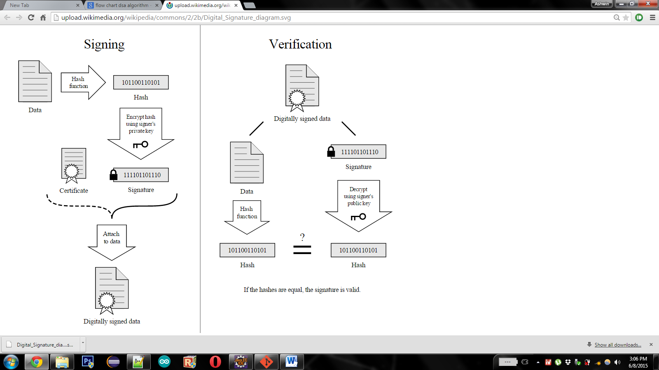

**7.3 Module Breakup**

* **Module 1:** Database design and DAO layer
* **Module 2:** Core operations (Algorithm Implementation)
* **Module 3:** OTP Generation
* **Module 4:** Voter Registration and Access
* **Module 5:** Election Lookup and Casting
* **Module 6:** Election Analytics
* **Module 7:** Admin Based operations
* **Module 8:** Election Process
* **Module 9:** Deployment in JBoss
* **Module 10:** Load Balancing in JBoss